

Politecnico di Milano  
A.A. 2015-2016  
Software Engineering 2 Project

My Taxi Service

Integration Test Document  
(ITD)

Giovanni Brena (858328), Andrea Canale (858638)

Contents

1. Introduction
   1. Revision History …………………………………………………. 3
   2. Purpose and Scope ..…………………………………………… 3
   3. Definitions, Acronyms, Abbreviations ………………………… 3
   4. Reference Documents ………………………………………….. 3
2. Integration Strategy
   1. Entry Criteria…………………...…………………………………. 4
   2. Elements to be integrated………………………………………. 4
   3. Integration Testing Strategy ……………………………………. 4
   4. Components Integration ………………………………………... 4
   5. Software Integration …………………………………………..… 5
3. Steps and Test Decription………………………………………………... 7
4. Program Stubs and Test Data…………………………………………… 11
5. Introduction  
   1. Revision History  
        
      This document is currently at revision: 1.  
      No previous revisions.
   2. Purpose and Scope  
        
      This document provides a strategy to achieve a complete and fully tested integration between components and software modules of MyTaxiService project. The main topic is to ensure the correct behavior of any interface connecting modules or subsystems through an integration process.
   3. Reference Documents  
        
      The following documents has been used as references for MyTaxiService Project:
      * + MyTaxiService Requirement Analysis and Specification Document (RASD)
        + MyTaxiService Design Document (DD)

The following documents has been used as external guidelines while writing this ITD:

* + - * Assignement 4 – integration test plan
      * Integration Test Plan Example

1. Integration Strategy  
   1. Entry Criteria  
        
      All components have to be unit tested before the integration test in order to provide atomic robustness to the system.  
      The following items must be delivered before integration testing begin:
      * + MyTaxiService Requirement Analysis and Specification Document (RASD)
        + MyTaxiService Design Document (DD)
        + Integration Testing Plan Document
   2. Elements to be integrated  
        
      All subsystems and components will be submitted to integration test through a step-by-step integration process.  
      * + Client Subsystem
        + Server Application Subsystem
        + Core Subsystem
   3. Integration Testing Strategy  
        
      A bottom-up testing strategy will be followed, mixed with top-down approach for high-level integration. Subsystems modules will be integrated first, then process will join subsystems together.
   4. Components Integration  
        
      Subsystems integration will based on the following chart, providing integrity to the Server subsystems as base to Client integration.  
        
      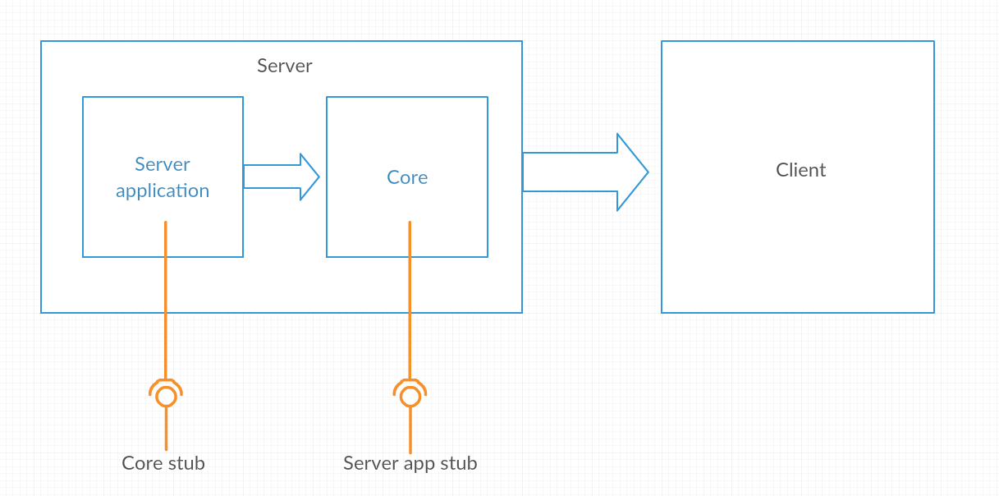
   5. Software Integration  
      * + Server Application Components

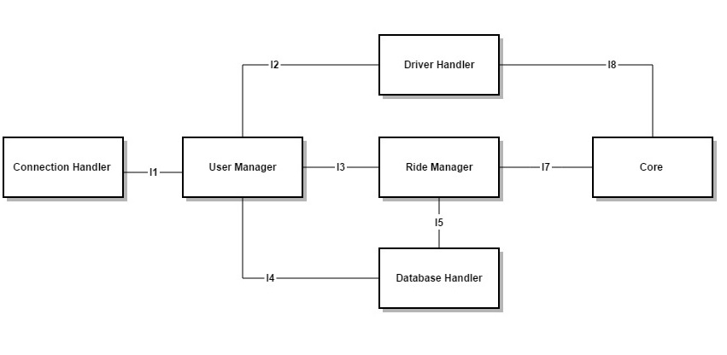

|  |  |  |
| --- | --- | --- |
| ID | Integration Test | Paragraphs |
| I1 | ConnectionHanlder->UserManagement | 3.1 |
| I2 | UserManagement->Driver Handler | 3.2 |
| I3 | UserManagement->Ride Manager | 3.3 |
| I4 | UserManagement->DatabaseHandler | 3.4 |
| I5 | RideManager->DatabaseHandler | 3.5 |
| I6 | (SubSystem)Core Integration Test |  |
| I7 | Driver Handler->Core | 3.6 |
| I8 | RideManager->Core | 3.7 |

* + - * Core Components

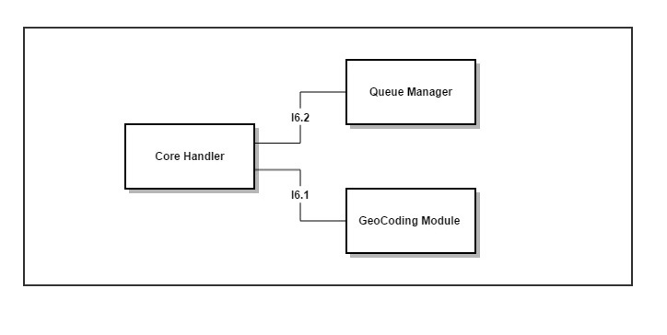

|  |  |  |
| --- | --- | --- |
| ID | Integration Test | Paragraphs |
| I6.1 | CoreHandler->GeoCodingModule | 3.8 |
| I6.2 | UserManagement->Queue Manager | 3.9 |

1. Steps and Test Description  
   1. ConnectionHanlder->UserManagement

|  |  |
| --- | --- |
| Test Case Identifier | I1 |
| Test Item(s) | ConnectionHanlder->UserManagement |
| Input Specifications | Incoming connection requests, Personal data management |
| Output Specifications | Profile persistent data manipulation |
| Environmental Needs | Client Driver |
|  |  |

* 1. UserManagement->Driver Handler

|  |  |
| --- | --- |
| Test Case Identifier | I2 |
| Test Item(s) | UserManagement->Driver Handler |
| Input Specifications | Set availability |
| Output Specifications |  |
| Environmental Needs | I1 succeeded |

* 1. UserManagement->Ride Manager

|  |  |
| --- | --- |
| Test Case Identifier | I3 |
| Test Item(s) | UserManagement->Ride Manager |
| Input Specifications | Ride data flow (request, start, interrupt, terminate) |
| Output Specifications | Ride data flow responses |
| Environmental Needs | I1 succeeded |

* 1. UserManagement->DatabaseHandler

|  |  |
| --- | --- |
| Test Case Identifier | I4 |
| Test Item(s) | UserManagement->DatabaseHandler |
| Input Specifications | Store, Update personal data |
| Output Specifications | Retrieve personal data |
| Environmental Needs | I1 succeeded |

* 1. RideManager->DatabaseHandler

|  |  |
| --- | --- |
| Test Case Identifier | I5 |
| Test Item(s) | RideManager->DatabaseHandler |
| Input Specifications | Store ride data |
| Output Specifications | Retrieve ride data |
| Environmental Needs | N/A |

* 1. RideManager->Core

|  |  |
| --- | --- |
| Test Case Identifier | I7 |
| Test Item(s) | RideManager->Core |
| Input Specifications | Taxi driver requests, Geocoding |
| Output Specifications | Availability requests |
| Environmental Needs | I3 succeeded,I6(SubSystem) succeedded |

* 1. Driver Handler->Core

|  |  |
| --- | --- |
| Test Case Identifier | I8 |
| Test Item(s) | Driver Handler->Core |
| Input Specifications | Taxi availability management, Geocoding requests |
| Output Specifications | Queue management responses, Coordinates |
| Environmental Needs | I2 succeeded,I6(SubSystem) succeedded |

* 1. CoreHandler->GeoCodingModule

|  |  |
| --- | --- |
| Test Case Identifier | I6.1 |
| Test Item(s) | CoreHandler->GeoCodingModule |
| Input Specifications | Geocoding requests, taxi tracking |
| Output Specifications | Coordinates |
| Environmental Needs | N/A |

* 1. UserManagement->Queue Manager

|  |  |
| --- | --- |
| Test Case Identifier | I6.2 |
| Test Item(s) | UserManagement->Queue Manager |
| Input Specifications | Queue management operation requests |
| Output Specifications | N/A |
| Environmental Needs | N/A |

1. Program Stubs and Test Data

Testing process will need the following programs stubs and driver during integration:

* Client driver and Core stub for Server Application software integration
* Server stub for Core software integration
* Data storage environment for all the integration process